**DAILY ONLINE ACTIVITIES SUMMARY**

|  |  |  |  |  |  |  |  |  |
| --- | --- | --- | --- | --- | --- | --- | --- | --- |
| **Date:** | **16/06/2020** | | | | | **Name:** | **ASHISH GRACION MENEZES** | |
| **Sem & Sec** | **4&A** | | | | | **USN:** | **4AL18CS012** | |
| **Online Test Summary** | | | | | | | | |
| **Subject** | | **COMPLEX ANALYSIS,PROBABILITY AND STATISTICAL METHODS** | | | | | | |
| **Max. Marks** | | **30** | | **Score** | | | **24** | |
| **Certification Course Summary** | | | | | | | | |
| **Course** | **MICROSOFT AZURE ESSENTIALS** | | | | | | | |
| **Certificate Provider** | | | **Great Learning** | | **Duration** | | | **12 HOURS** |
| **Coding Challenges** | | | | | | | | |
| **Problem Statement1:Write a C program to binary reversal of a number** | | | | | | | | |
| **Status:Executed** | | | | | | | | |
| **Uploaded the report in Github** | | | | | **YES** | | | |
| **If yes Repository name** | | | | | **https://github.com/ash7745/lockdown-coding** | | | |
| **Uploaded the report in slack** | | | | | **YES** | | | |

Online Test Details1: 18MAT41 test was conducted on 16/06/2020.The test consisted of 15 questions each question carrying 2 marks.The duration of the test was 40 minutes.The portion for I.A 5 was from 1st module.

Certification Course Details: MICROSOFT AZURE ESSENTIALS

Today I have started a new course .The course duration is of 12 hours.It contains of assessments which we have to complete with minimum of 80% of marks in order to obtain the e-certificate.Today I have learnt 8 modules each of duration 14,5,3,12,14,23,12,30 minutes

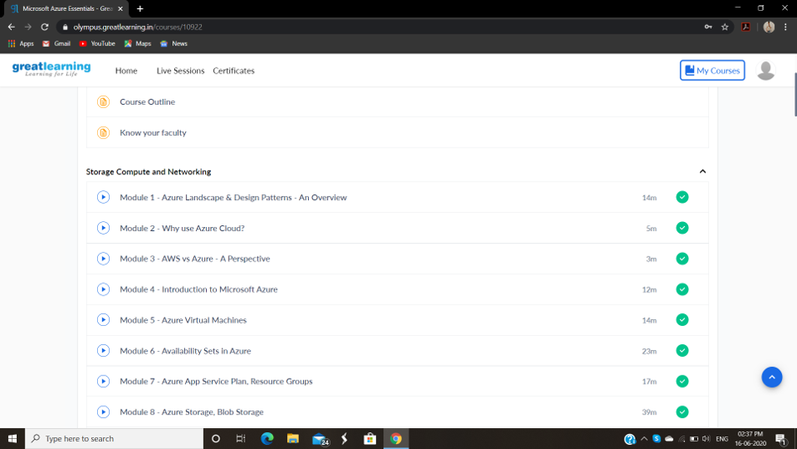

CODING DETAILS: Program to binary reversal of a number(using c language)

